Program 1

—----------------------------------------------------------------------------------------------------------------------

Write a shell script to find the sum, the average and the product of the four

integers entered

echo "Enter 4 numbers :"

read a b c d

sum=$((a+b+c+d))

avg=$((sum/4))

product=$((a\*b\*c\*d))

echo "Sum = $sum"

echo "Average = $avg"

echo "Product = $product"

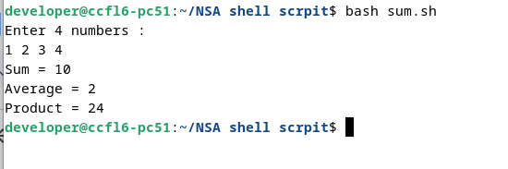

Program 2

—-----------------------------------------------------------------------------------------------------------------------

2 a) Write a program to check whether a number entered is odd or even.

b) Write a shell script to print given number in reverse order

c) Write a shell script to print sum of all digits of a given number

echo "Enter a number :"

read num

n=$num

while true;do

echo "Select one option"

echo "1.Check whether the no is odd or not"

echo "2.Reverse order of the number"

echo "3.Sum of digits"

echo "4.Exit"

echo "----------------------"

read choice

case $choice in

1)

echo "----------------------"

if (( num % 2==0 ))

then

echo "The number is even"

echo "----------------------"

else

echo "The number is odd"

echo "----------------------"

fi

;;

2)

echo "----------------------"

echo "Reverse Order"

rev=0

while [ $num -gt 0 ]

do

d=$((num % 10))

rev=$((rev\*10+d))

num=$((num/10))

done

echo $rev

echo "----------------------"

;;

3)

num=$n

echo "----------------------"

echo "Sum of digits"

sum=0

while [ $num -gt 0 ]

do

d=$((num % 10))

sum=$((sum+d))

num=$((num/10))

done

echo $sum

echo "----------------------"

;;

4)

echo "Exiting"

echo "----------------------"

break

;;

\*)

echo "invalid option"

esac

done

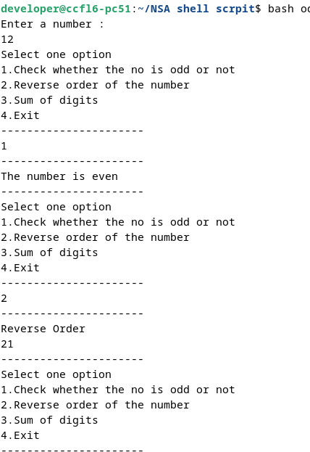

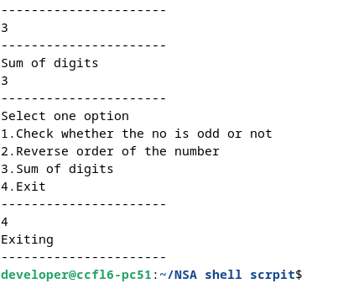

Program 3

—-----------------------------------------------------------------------------------------------------------------------

3 Write a shell script that accepts any year from the keyboard and determine

whether the year is a leap year or not.

echo "Enter a year :"

read y

if(((y %4==0 && y%100!=0) || (y%400==0)))

then

echo " $y is Leap year"

else

echo "$y is not a leap year"

fi

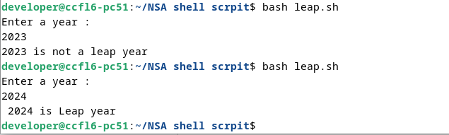

Program 4

—----------------------------------------------------------------------------------------------------------------------

4. Write a shell script to find the factorial of a number

echo "Enter a number :"

read num

f=1

for((i=1;i<=num;i++))

do

f=$((f\*i))

done

echo "Factorail= $f"

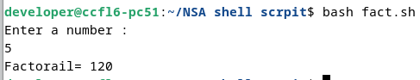

Program 5

—---------------------------------------------------------------------------------------------------------------------------

5. Write a program to print prime numbers from 1 to 100

echo "Prime numbers"

for ((num=2; num<=100; num++))

do

for ((i=2; i<num; i++))

do

if ((num % i == 0)); then

break

fi

done

if ((i == num)); then

echo $num

fi

done

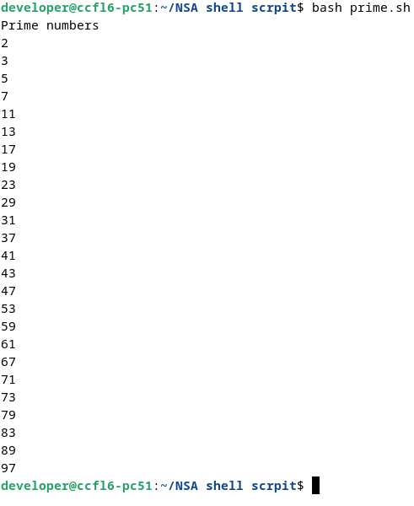

Program 6

—--------------------------------------------------------------------------------------------------------------------

6. Write a script for printing Numbers in ascending order

echo "Enter 1st number"

read n1

echo "enter 2nd number"

read n2

for((i=n1;i<=n2;i++))

do

echo $i

done

